

T
ues

Mar 21,2023

Electrical engineer
ing
Department

Banha University
.

Shoubra Faculity
o
f

E
ngineering
.

[
this is a report about project audio amplifier show you the function of the circuit
and the schematic and PCB design]

Report
Audio
[
Amplifier
]

.




Report[ Audio Amplifier ]

Report[ Audio
Amplifier ]

.

SPECIFICATION:

•

Nice load output from
Speaker.

•

I
nput
impe
dance greater than 10k ohm

•

Input from
USB player

•

V
olume
co
ntrol

•

C
apacitors to gain nice voice

Explaining project :

An audio power amp
lifier is an electronic
amplifier low
-
power audio signals(signals
composed primarily of
frequenc
i
es
between
20
-
20000
HZ, the human range of hearing)
to a level suitable
for driving
loudspeaker .Our
audio amplifier is capable
of t
aking DC to IC and to giving out put

to
the Speaker

. the IC

which is used in our
Aud
io
Amplifier.



Report[ Audio Amplifier ]

4

project is (LM
386)
needs (
-
12
-
)
12
V

DC

to power
up ou
r ci
rcuit

an
d we
gain this volt from
A
daptor
.

W
e
drive
the small signal from
T
he
socket

the
n to potentiometer then
to pin (
3)

(
T
he
input pin
)
.

W
e
use potentiometer to
enable u
s to change the volume of the sound
freely.

Then

we put capacitors (100uf and 47 nf )to move any
d
istributio
n
to Pin (6
)

(
Vs pin
)
.

•

Finally ,

we get the large sig
nal f
rom pin (5)(the out put pin ) which is
capable with capacitor (220uf)

which is parallel to
resistance

(
10
Ohm ) and

capacitor (47nf)

an
d this step help us to gain
purely

and

larger sound

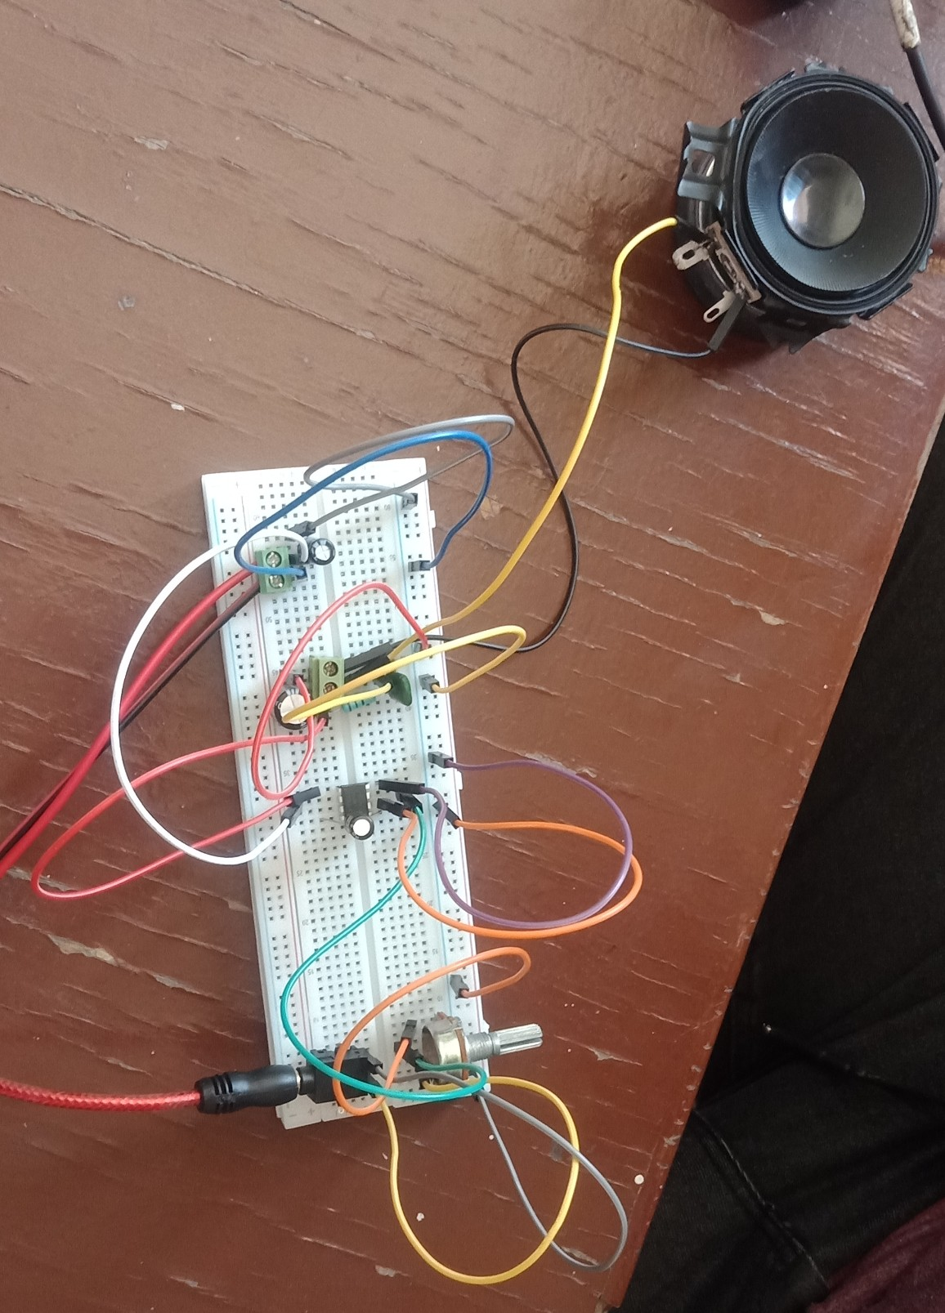


Report[ Audio Amplifier ]

Circuit BreadBoard


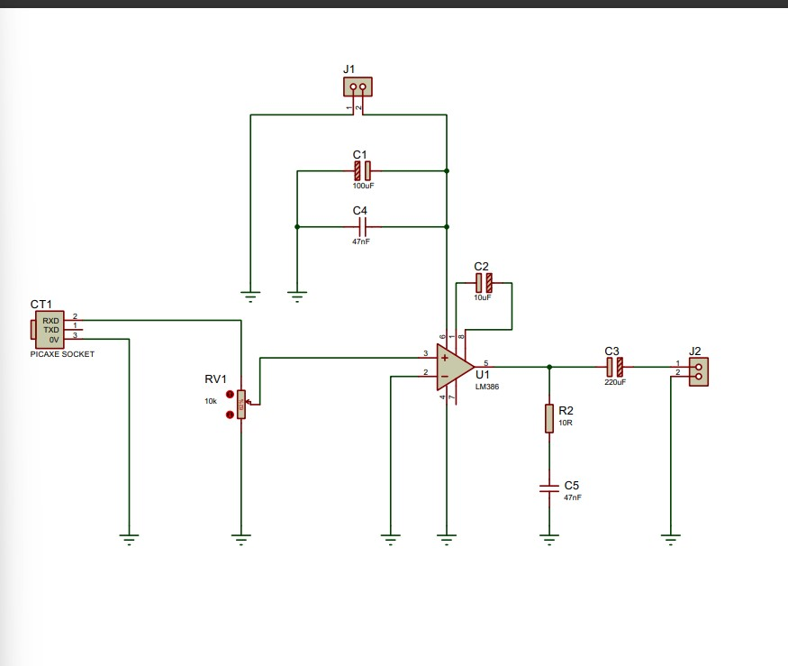

Report[ Audio Amplifier ]

6

Ci
rcuit Schematic

This design is done on PROTEUS Soft
ware .


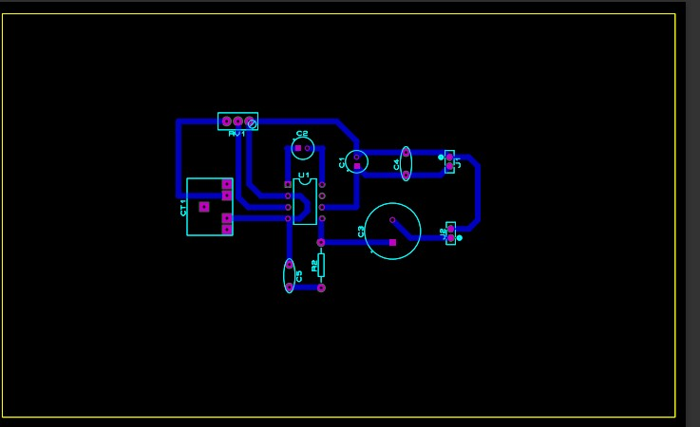

Report[ Audio Amplifier ]

Circuit PCB Layout

U
s
ing
pr
oteus soft ware

